**NAAN MUDHALVAN** **MANDATORY COURSE**

**AUGUST – DECEMBER 2023** **(ODD SEMESTER)**

**DATA ANALYTICS WITH TABLEAU**

**Course Name:** Data Analytics With Tableau

**Team Number:** 22

**Assignment Submitted To:** Anna University – Naan

Mudhalvan

**Year:**IV

**Department:** AI&DS

**Semester:** VII

**Team Members:** 1.Bernancy Irudhaya.J

2.Veerapandiyan .V

3.Akash Kumar. P

4.Janani .P

**Guided By:** Ms.M.Noorunnisha – AP / CSE (Mamce – 8126)

**SPOC Name:** Dr.K.Manikandan

**ASSIGNMENT QUESTION**

Upload the dataset to Cognos Analytics, prepare the data, explore and Create Interactive Dashboard, Report and Story.

**ASSIGNMENT SOLUTION SCREENSHOTS**

**HR Dataset Analysis**

**Dashboard :**

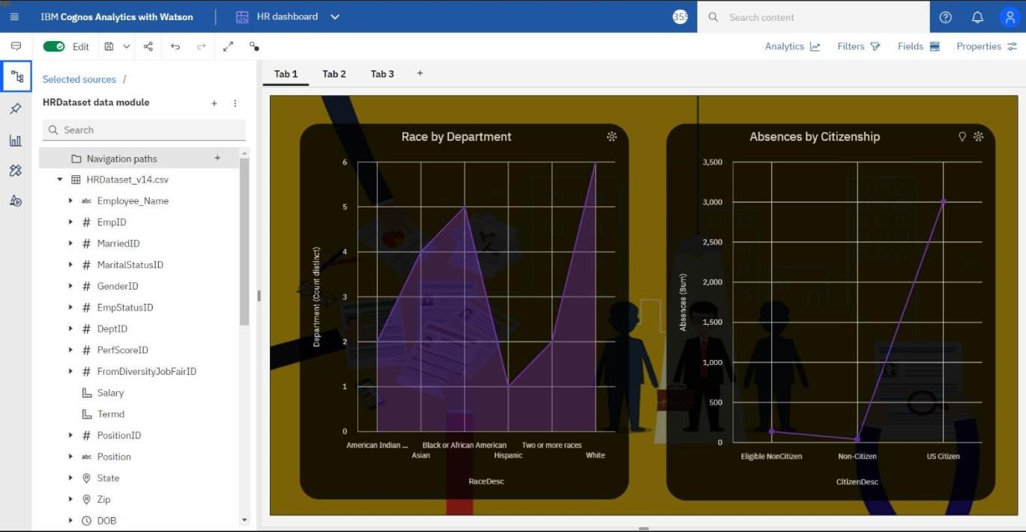

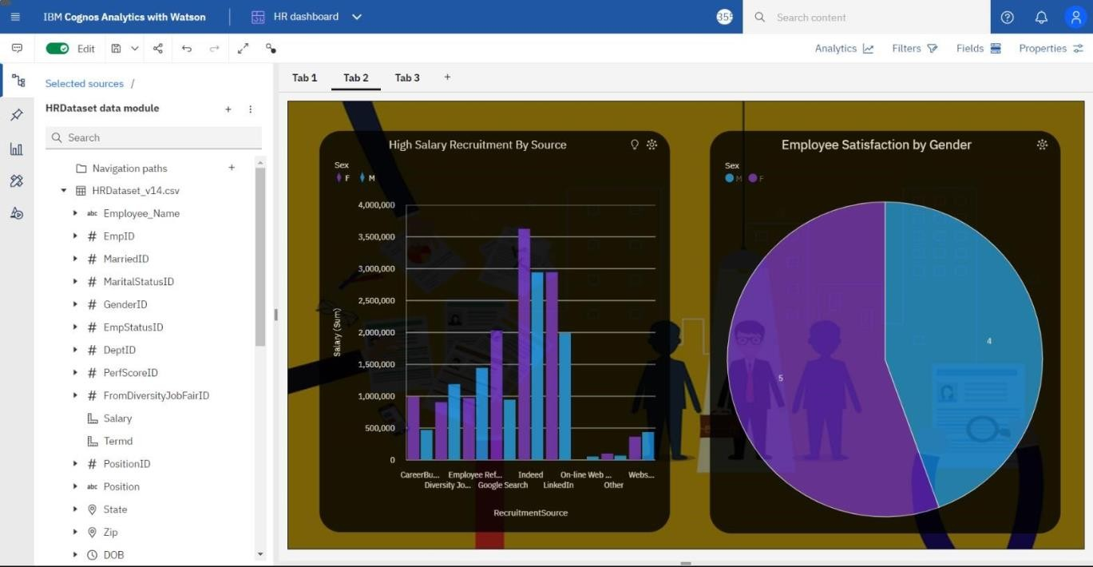

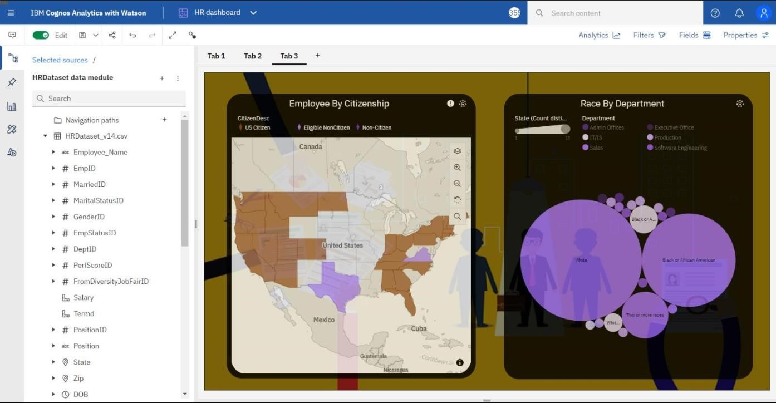

**Story :**

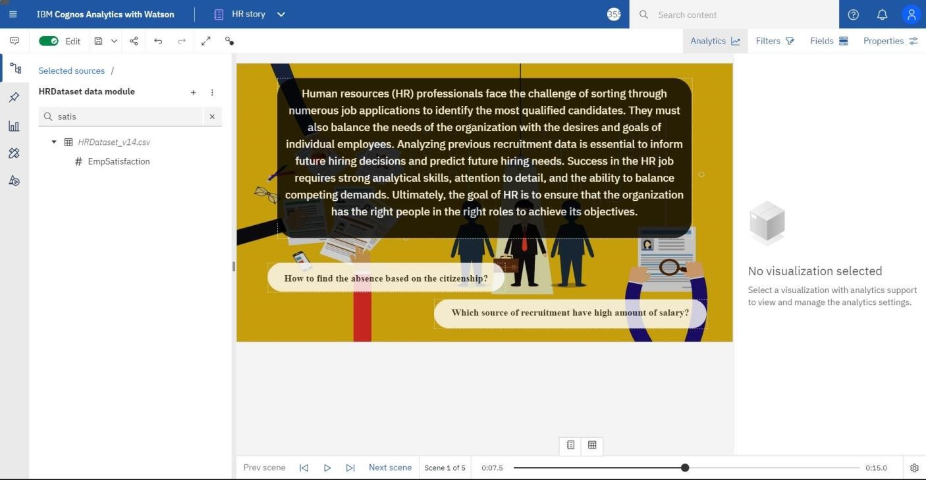

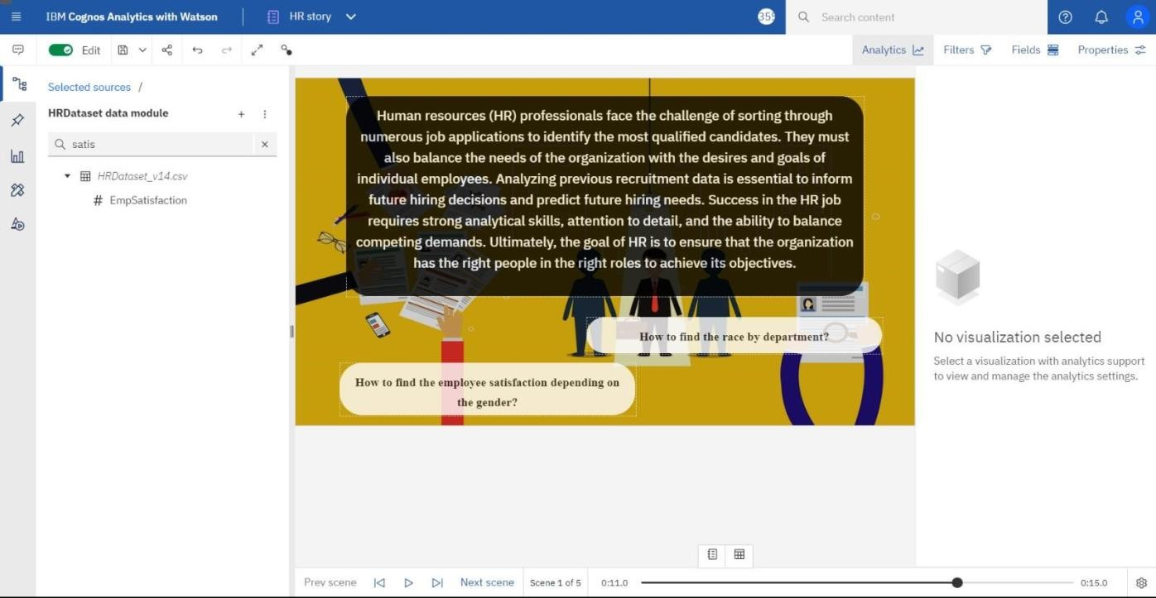

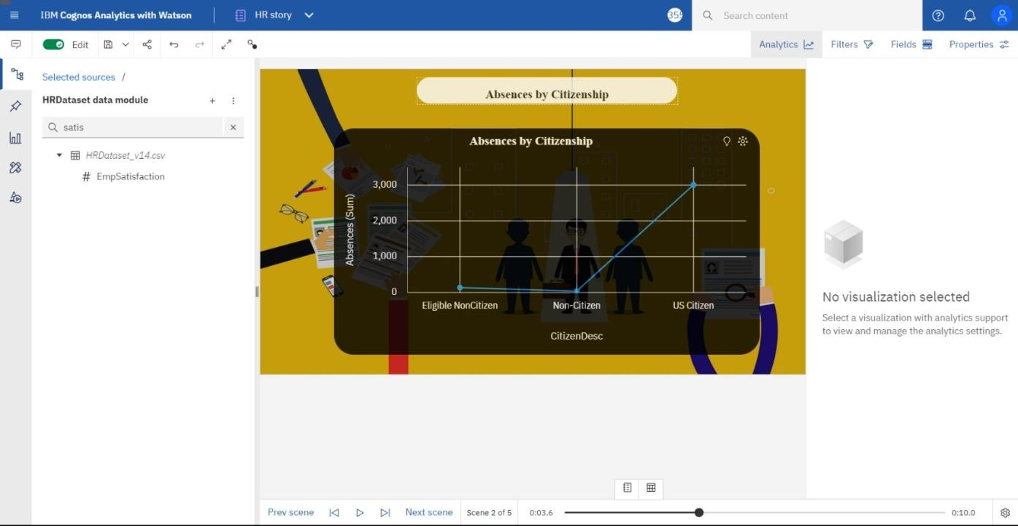

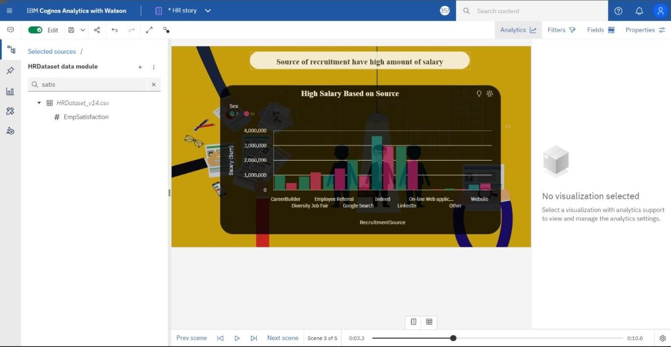

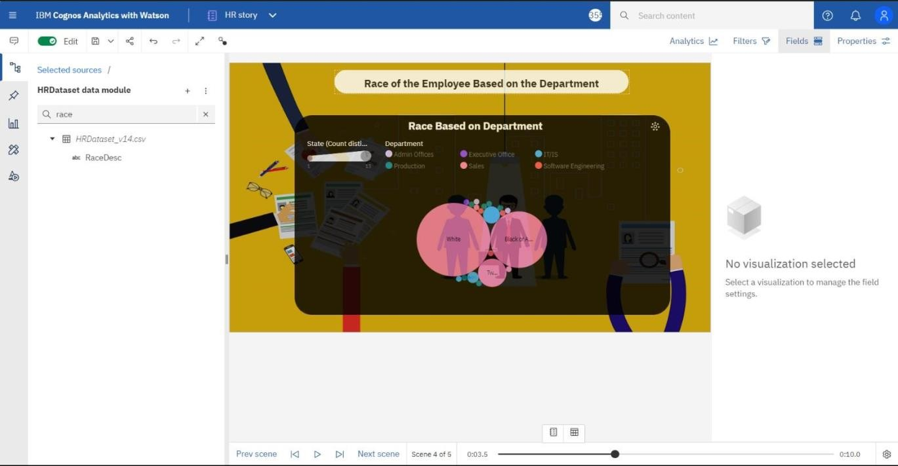

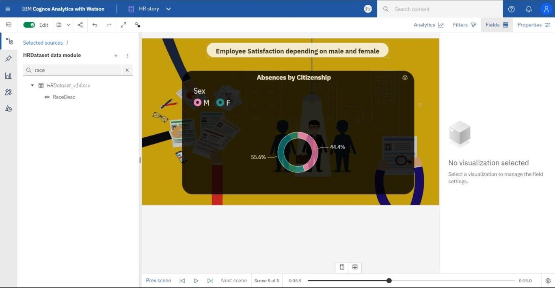

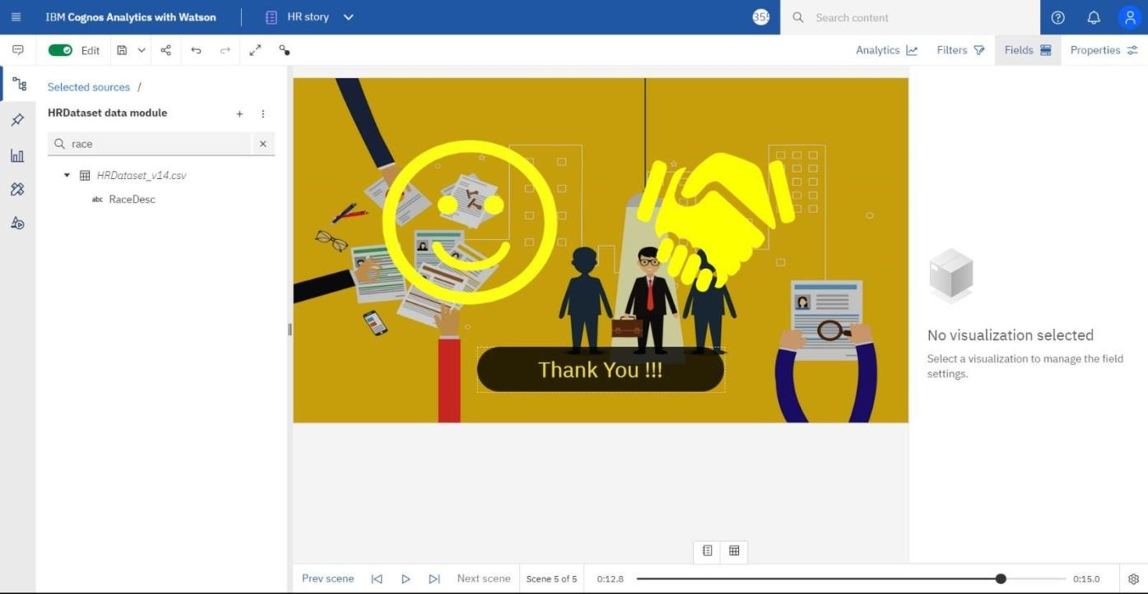

**HR Data Report :**

